تغییرات دبی، شوری آب و حجم رسوبات، تغییر ریخت شناسی بستر، حریم و اکوسیستم رودخانه در پایین دست از جمله پیامدهای مستقیم سد سازی می باشد. Jafari, 2017 نشان داد که دبی بیشینه و شوری رودخانه کارون تحت اثر سدسازی ها و اقلیم طی یک بازه 50 ساله از 1969 تا 2016 به ترتیب 0.5 و 1.5 برابر شده است

تغییرات هیدرولوژیکی ناشی از ساخت سد بر اکوسیستم‌های رودخانه‌ای تأثیر می‌گذارد که می تواند منجر به انزوا و تکه تکه شدن زیست بوم ها، کاهش تنوع زیستی، شیلات دشت سیلابی و خدمات اکوسیستم های مرتبط با رودخانه ‌شود (Zeiringer et al., 2018; Zhang et al., 2022).

سدها دبی پایین دست رودخانه را تغییر می دهند که جهت و آهنگ تغییرات بسته به شدت خشکسالی می تواند، تشدید نیز گردد.

White et al., 2023 تأثیرات خشکسالی بر دمای آب رودخانه را مطالعه کردند. Yang et al., 2022 نشان داد که سد سازی می تواند دمای اب رودخانه را افزایش دهد. Liu et al., 2016 نقش سدسازی ها و تغییرات اقلیمی بر تشدید خشکسالی و تغییر چشم انداز پایین دست رودخانه را تأیید کردند.

et al., 2022 Zheng سدسازی می تواند به کنترل سیل در پایین دست کمک کند. در عین حال، می تواند منجر به کاهش قابل توجه دبی، تغییر دشت های سیلابی و کانال های رودخانه نیز شود .

تأثیر سدها بر جریان دبی سالانه در دوره های ترسالی و خشکسالی متفاوت است. در دوره های مرطوب تأثیر سدها مشهود نیست، ولی در دوره های خشکسالی نقش آن ها در کاهش دبی ملموس می باشد (Zheng et al., 2019).

بسیاری از مطالعات پیشین تغییرات دبی در پایین دست رودخانه را یکی از نتایج مهم ساخت و آبگیری سدها برشمردند.

مطالعات پیشین، تغییرات دبی تحت تأثیر سدسازی را

Liu, Y., Wu, G., Guo, R., & Wan, R. (2016). Changing landscapes by damming: the Three Gorges Dam causes downstream lake shrinkage and severe droughts. *Landscape Ecology*, *31*, 1883-1890.

White, J. C., Khamis, K., Dugdale, S., Jackson, F. L., Malcolm, I. A., Krause, S., & Hannah, D. M. (2023). Drought impacts on river water temperature: A process‐based understanding from temperate climates. *Hydrological Processes*, *37*(10), e14958.

Yang, R., Wu, S., Wu, X., Ptak, M., Li, X., Sojka, M., ... & Zhu, S. (2022). Quantifying the impacts of climate variation, damming, and flow regulation on river thermal dynamics: a case study of the Włocławek Reservoir in the Vistula River, Poland. *Environmental Sciences Europe*, *34*(1), 1-11.

Zeiringer, B., Seliger, C., Greimel, F., & Schmutz, S. (2018). River hydrology, flow alteration, and environmental flow. *Riverine ecosystem management: Science for governing towards a sustainable future*, 67-89.

Zhang, X., Fang, C., Wang, Y., Lou, X., Su, Y., & Huang, D. (2022). Review of effects of dam construction on the ecosystems of river estuary and nearby marine areas. *Sustainability*, *14*(10), 5974.

Zhang, Y., Xia, J., Liang, T., & Shao, Q. (2010). Impact of water projects on river flow regimes and water quality in Huai River Basin. Water Resources Management, 24, 889-908.

Zheng, Y., Zhang, G., Wu, Y., Xu, Y. J., & Dai, C. (2019). Dam effects on downstream riparian wetlands: the Nenjiang River, Northeast China. *Water*, *11*(10), 2038.

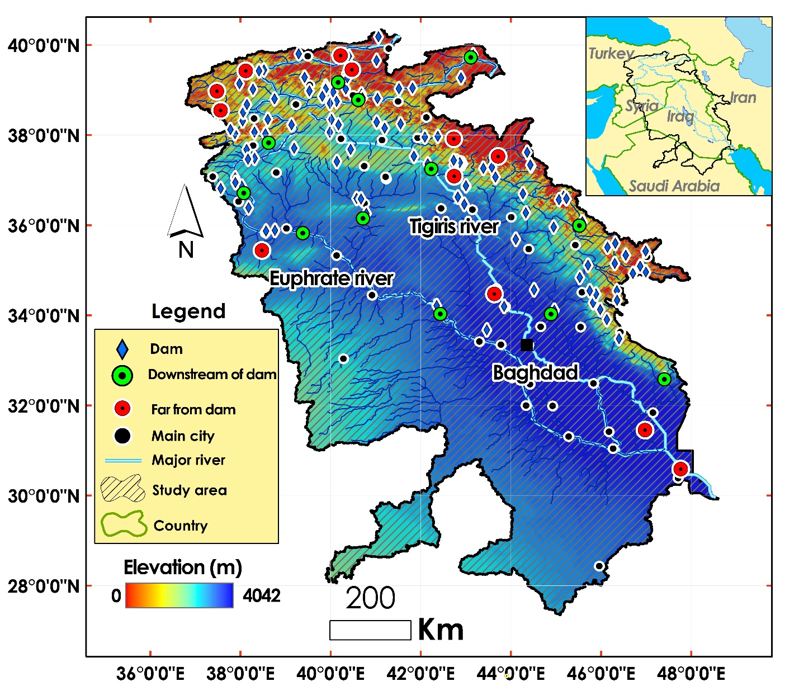

Fig. 1. The Tigris and Euphrates Basin (TEB). The operated dams, selected points in downstream and far from of dams have been shown.

دوازده نقطه در طول مسیر رودخانه ها و چند کیلومتری پایین دست دریاچه های سدها برای ارزیابی و تحلیل مکانی- زمانی تأثیر سدها (عامل انسانی) و خشکسالی (عامل اقلیمی) بر دبی در TEB انتخاب شد. همچنین دوازده نقطه با بیشترین فواصل و کمترین تأثیرپذیری از سدها، به عنوان نقاط شاهد انتخاب شدند. نقاط انتخابی نزدیک به و دور از سدها، در مسیر رودخانه های اصلی و فرعی و حتی الامکان با پراکندگی یکنواختی توزیع شده اند.

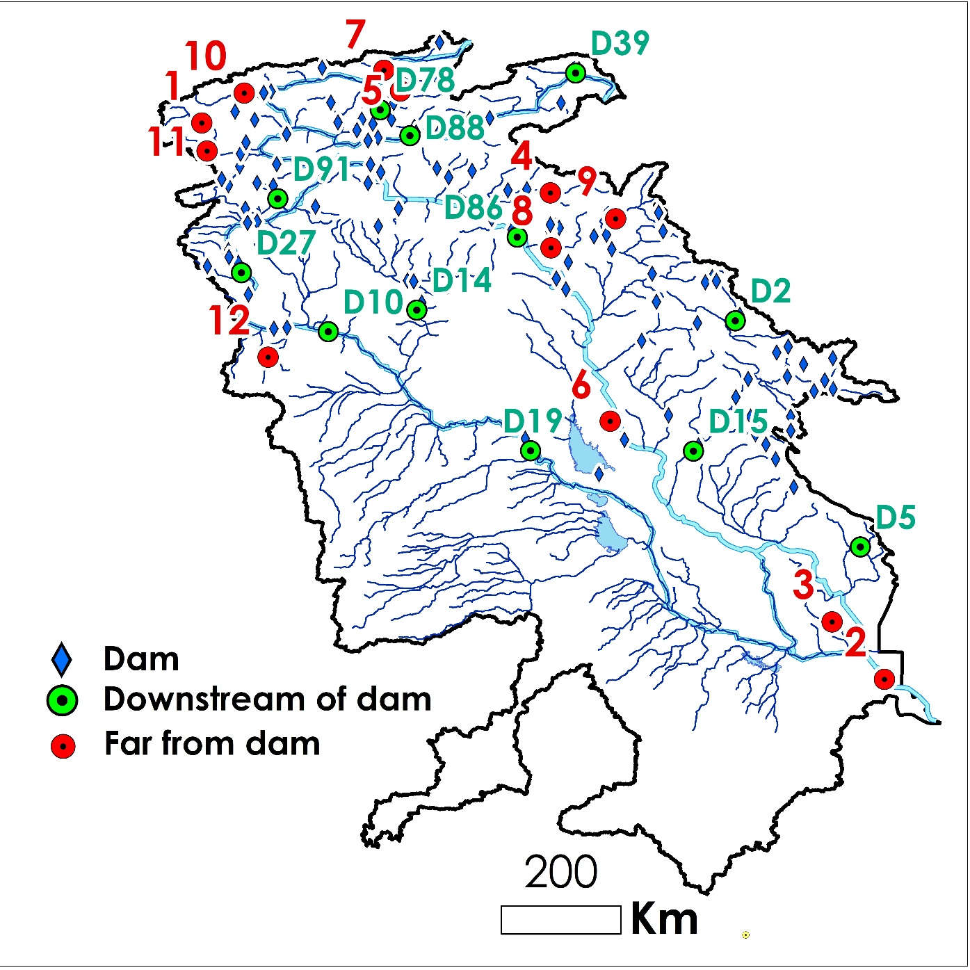

Fig. 1. Spatial distribution of the selected points in downstream and far from of dams within TEB

Table 1- The attributes of the selected dams in TEB. Dust events obtained from <https://data.mendeley.com/datasets/7937gn7g8c/1> (Darvishi Boloorani et al., 2023)

|  |  |  |  |  |  |  |  |  |
| --- | --- | --- | --- | --- | --- | --- | --- | --- |
| **ID** | **Code** | **Name** | **River** | **Basin** | **Country** | **Operation year** | **Functions** | **Volume (MCM[1])** |
| **1** | D19 | Haditha | Euphrates | Euphrates | Iraq | 1987 | Irrigation/ Hydro Power | 8280 |
| **2** | D39 | Yazici | Altincayir | Euphrates | Turkey | 2009 | Irrigation | 196 |
| **3** | D88 | Lower Kaleköy | Murat | Euphrates | Turkey | 2019 | Hydro Power | 516.5 |
| **4** | D27 | Karkamis | Euphrates | Euphrates | Turkey | 2000 | Hydro Power/ Flood Control | 160 |
| **5** | D91 | Sırımtaş | Birimşe | Euphrates | Turkey | 2013 | Hydro Power | 60 |
| **6** | D78 | Yedisu | Peri | Euphrates | Turkey | 2012 | Hydro Power | 5 |
| **7** | D86 | Ilısu | Tigris | Tigris | Turkey | 2018 | Irrigation/ Hydro Power/ Flood Control | 10410 |
| **8** | D10 | Baath | Euphrates | Euphrates | Syria | 1987 | Irrigation/ Hydro Power/ Flood Control | 90 |
| **9** | D14 | Bassel Al Assad | Khabur | Euphrates | Syria | 2001 | Irrigation | 605 |
| **10** | D15 | Hamrin | Diyala | Tigris | Iraq | 1981 | Irrigation/ Flood Control | 2450 |
| **11** | D2 | Sardasht | Lesser_Zab | Tigris | Iran | 2017 | Irrigation/ Hydro Power | 387 |
| **12** | D5 | Dwairej | Dwairej | Tigris | Iran | 2013 | Irrigation | 205 |

|  |  |
| --- | --- |
| **Annual discharge and drought changes of the points in downstream of dams** | |
|  |  |
|  |  |
|  |  |
|  |  |
|  |  |
|  |  |

Fig. 3. Annual discharge and PDSI changes of the downstream points of dams during 1979 to 2022. PDSIs were categorized in 8 classes from extremely drought (highest red vertical dash line) to extremely wet (highest blue vertical dash line). The operation year of dams are distinguishable in plots.

|  |  |
| --- | --- |
| **Annual discharge and drought changes in sample points far from dams** | |
|  |  |
|  |  |
|  |  |
|  |  |
|  |  |
|  |  |

Fig. 4. Annual discharge and PDSI changes of the downstream points far from dams during 1979 to 2022.

Time series analysis (TSA) methods were used to detect the trend of monthly discharge values in the dam downstream points. Those methods capture the relationship between a time series and its lagged values that can analyze the interdependencies among different time series. TSA could identify the regime shifts in time series data. Breaks For Additive Season and Trend (BFAST) model decomposes elements of time series. BFAST integrates the decomposition of time series into trend, season, and residual components. It’s particularly effective for detecting changes within time series data. BFAST iteratively detects changes by fitting piecewise linear models to the trend component of the time series (Verbesselt et al., 2010; Piwowar and LeDrew, 2002).

**Monthly discharge trending of** **the points in downstream of dams (from 1979 to 2022)**

|  |  |  |
| --- | --- | --- |
| |  | | --- | |  | |  |
| Trend= decreasing, Slope= -0.2147 | No trend |
|  |  |
| Trend= decreasing, Slope= -0.0562 | Trend= decreasing, Slope= -0.0707 |
|  |  |
| No trend | Trend= decreasing, Slope= -0.0096 |
|  |  |
| Trend= decreasing, Slope= -0.0498 | Trend= decreasing, Slope= -0. 1561 |
|  |  |
| Trend= decreasing, Slope= 0.0039 | Trend= decreasing, Slope= -0.0010 |
|  |  |
| No trend | No trend |

Fig. 5. The monthly discharge trend of the downstream points of the selected dams using TSA model from 1979 to 2022.

|  |  |
| --- | --- |
|  |  |
|  |  |
|  |  |
|  |  |
|  |  |
|  |  |
|  |  |

Fig. 6. Trend and seasonality components of monthly discharge trending for selected dams with certain trends.

|  |  |
| --- | --- |
| Trending of sample points before dam cnostruction | |
|  |  |
| No trend | No trend |
|  |  |
| Trend= decreasing, Slope= -0.0419 | No trend |
|  |  |
| No trend | No trend |
|  |  |
| Trend= decreasing, Slope= -0.060 | No trend |
|  |  |
| No trend | No trend |
|  |  |
| No trend | No trend |

Fig. 4. Trending of monthly discharge of selected dams using TSA model from 1979 to the dam construction year.

|  |  |
| --- | --- |
|  |  |
|  |  |

Fig. 5. Trend and seasonality components of monthly discharge trending for selected dams from 1979 to the dam construction year for dams with certain trends.

|  |  |
| --- | --- |
| Trending of sample points after dam cnostruction | |
|  |  |
| Trend= decreasing, Slope= -0.2234 | Trend= decreasing, Slope= -0.0525 |
|  |  |
| No trend | No trend |
|  |  |
| No trend | No trend |
|  |  |
| Trend= decreasing, slope= -2.5034 | Trend= decreasing, slope= -0.1591 |
|  |  |
| No trend | Trend= decreasing, Slope= -0.00108 |
|  |  |
| No trend | No trend |

Fig. 6. Trending of monthly discharge of selected dams using TSA model from the dam construction year to 2022.

|  |  |
| --- | --- |
|  |  |
|  |  |
|  |  |
|  |  |
|  |  |
|  |  |

Fig. 7. Trend and seasonality components of monthly discharge trending for the selected dams from the dam construction year to 2022 for dams with certain trends.

**Monthly discharge trending of the sample points far from the dams (from 1979 to 2022)**

|  |  |  |
| --- | --- | --- |
| |  | | --- | |  | |  |
| Trend= decreasing, Slope= -0.0002 | Trend= decreasing, Slope= -0.5163 |
|  |  |
| Trend= decreasing, Slope= -0.1591 | No trend |
|  |  |
| Trend= decreasing, Slope= -0.0037 | Trend= decreasing, Slope= -0.0863 |
|  |  |
| Trend= decreasing, Slope= -0.0077 | Trend= decreasing, Slope= -0. 0053 |
|  |  |
| No trend | Trend= decreasing, Slope= -0.0039 |
|  |  |
| Trend= decreasing, Slope= -0.0001 | Trend= decreasing, Slope= -0.0001 |

Fig. 8. The monthly discharge trend of the points far from the dams using TSA model from 1979 to 2022.

|  |  |
| --- | --- |
|  |  |
|  |  |
|  |  |
|  |  |
|  |  |
|  |  |
|  |  |
|  |  |
|  |  |

Fig. 9. Trend and seasonality components of monthly discharge trending for the points far from dams with certain trends.

|  |  |
| --- | --- |
| Relationship between Annual discharge and PDSI | |
|  |  |
|  |  |
|  |  |
|  |  |
|  |  |
|  |  |

Fig. 10. The scatter plots showing the correlation between annual discharge and PDSI of the selective dams from 1979 to the dam construction date (blue color) and the dam construction year to 2022 (orange color). X-axis and y- axis values show the annual PDSI and discharge, respectively.

|  |  |
| --- | --- |
| Correlation between Annual discharge and PDSI for the points far from dams | |
|  |  |
|  |  |
|  |  |
|  |  |
|  |  |
|  |  |

Fig. 11. The scatter plots showing the correlation between annual discharge and PDSI of the points far from dams from 1979 to 2022.

|  |
| --- |
| a |
| b |

Fig. 12. Histogram comparing the average annual discharge (a) and PDSI (b) of the selected dams to each other for 1979 to the dam construction year (blue color) and after the dam construction year to 2022 (orange color).

|  |  |
| --- | --- |
| a | b |

Fig. 13. Histogram comparing the average annual discharge (a) and PDSI (b) of the selected points far from dams to each other from 1979 to 2022.

|  |
| --- |
| Fig. 14. The scatter plot showing the correlation between average annual discharge and PDSI of the selected dams for 1979 to the dam construction year (blue color) and after the dam construction year to 2022 (orange color).    Fig. 15. The scatter plot showing the correlation between average annual discharge and PDSI of the selected points far from dams for 1979 to 2022.  Degree of regulation (DOR); equivalent to residence time of water in the reservoir; calculated as ratio between storage capacity and total annual flow. DOR is a key concept in dam management, reflecting how much a dam can control the flow of water in a river system. It’s essentially a measure of a dam’s ability to manage water resources over time. The DOR is calculated by comparing the storage capacity of a dam’s reservoir to the average annual flow of the river. It’s expressed as a ratio or a percentage |
|  |
|  |

Fig. 16. The scatter plot showing the correlation between DOR and average annual discharge of the selected dams for 1979 to the dam construction year (blue color) and after the dam construction year to 2022 (orange color).

**References**

Cosgrove, D., & Petts, G. (Eds.). (1990). Water, engineering and landscape: water control and landscape transformation in the modern period (pp. vi+-214).

Harrigan, S., Zsoter, E., Alfieri, L., Prudhomme, C., Salamon, P., Wetterhall, F., ... & Pappenberger, F. (2020). GloFAS-ERA5 operational global river discharge reanalysis 1979–present. Earth System Science Data, 12(3), 2043-2060.

Piwowar, J. M., & LeDrew, E. F. (2002). ARMA time series modelling of remote sensing imagery: A new approach for climate change studies. *International Journal of Remote Sensing*, *23*(24), 5225-5248.

Verbesselt, J., Hyndman, R., Newnham, G., & Culvenor, D. (2010). Detecting trend and seasonal changes in satellite image time series. *Remote sensing of Environment*, *114*(1), 106-115.

1. -Million cubic meter (MCM)